CEO’s REPORT

# Executive Summary:

We aim to identify the elements of the video game market that most influence sales to decide what kind of game to make. Here is a comprehensive analysis of the position and market trends. This report delves into key insights derived from a thorough examination of video game sales data, providing strategic recommendations to guide our decision-making process.

# Key Insights:

## Top-selling Games and Revenue contributions

High-performing titles, including Wii Sports, Mario Kart Wii, and Wii Sports Resort, have significantly had a huge success in games Sales. We should capitalize on the success factors of these games for future releases.

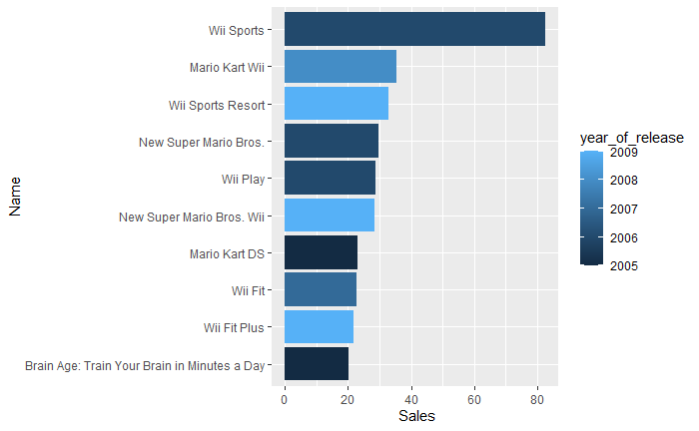

## Platform Performance and Market Share:

Consoles remain dominant, the most popular platforms are PS2, X360, and PS3. Donkey Games should invest in games that can play on the three platforms.

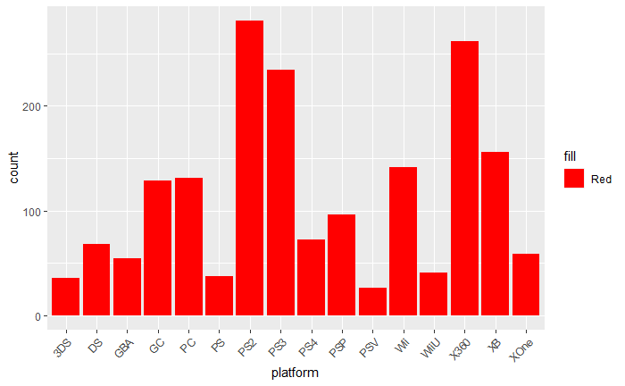

## User and Critic Scores Impact:

Positive reviews from both critics and users correlate strongly with higher sales. This reinforces the importance of quality content and effective marketing in driving revenue.

It is also possible for us to predict the performance of our game sales by using the critic score.

## Genre Sales

Action and sports have continued to dominate the sales market. compared to other genres.

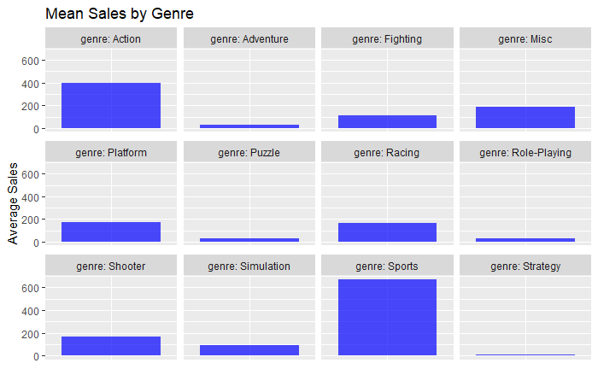

# Recommendations:

## Platform Diversification:

Consider expanding our footprint in the various modern platforms eg PS3 and X360. This aligns with the growing trend and diversifies our revenue streams.

## User Engagement Enhancement:

Prioritize user engagement strategies, including regular updates, responsive customer support, and maintaining a positive online presence. This will help us predict the sales performance of the games.

# Conclusion

In conclusion, the video game industry presents both challenges and opportunities. By leveraging the findings of this analysis, we are well-equipped to make informed decisions that will drive our success in this dynamic market.